भारत मौसम विज्ञान विभाग |  | India Meteorological Department
Thursday 21st May 2026 (31st Vaisakha 1948 Saka)
Summary of observations recorded at 0830 hours IST: The Northern Limit of Monsoon continues to pass through 6°N/70°E, 6°N/75°E, 7°N/80°E, 9°N/85°E, 12°N/90°E, 14°N/93°E, 16°N/96°E and 17.5°N/98°E. Conditions are favourable for further advance of southwest monsoon into some more parts of southeast Arabian Sea, Comorin Area, southwest and southeast Bay of Bengal, remaining parts of Andaman Sea, and some more parts of eastcentral Bay of Bengal during next 3-4 days. The Western disturbance as a trough in westerlies with its axis at 5.8 km above m. s. l. ran roughly along Long. 62°E to the north of Lat. 28°N. The upper air cyclonic circulation over Punjab & adjoining Pakistan lay over Punjab & neighbourhood at 0.9 km above m. s. l. The upper air cyclonic circulation over west Bihar & neighbourhood lay over East Uttar Pradesh & neighbourhood at 0.9 km above m. s. l. An east-west trough ran from Northwest Uttar Pradesh to Manipur across cyclonic circulation over East Uttar Pradesh, Bihar, north Gangetic West Bengal, and north Bangladesh at 0.9 km above m. s. l. The upper air cyclonic circulation over east Bangladesh & neighbourhood merged with the above east-west trough. The trough ran from East Uttar Pradesh to south coastal Odisha across Jharkhand and north Chhattisgarh and interior Odisha at 0.9 km above m. s. l. The trough in westerlies ran roughly along Long. 89°E to the north of Lat. 20°N at 3.1 km above m. s. l. The upper air cyclonic circulation over Gangetic West Bengal & adjoining Bangladesh lay over south Bangladesh and neighbourhood at 1.5 km above m. s. l. An upper air cyclonic circulation lay over south coastal Odisha and neighbourhood at 1.5 km above m. s. l. The trough from southeast Arabian Sea to the central Bay of Bengal ran from central Bay of Bengal to Tamil Nadu across southwest Bay of Bengal between 3.1 & 4.5 km above m. s. l. An upper air cyclonic circulation lay over north Haryana & neighbourhood at 1.5 km above m. s. l. The Western Disturbance as a cyclonic circulation over north Pakistan and adjoining Jammu became less marked. The upper air cyclonic circulation over central parts of north Uttar Pradesh became less marked at 0530 hrs IST of today morning.
Maximum Temperature Departures (as on 20-05-2026): markedly above normal (> 5.1°C) at few places over Arunachal Pradesh, Uttarakhand, Haryana-Chandigarh-Delhi, Punjab, Jammu-Kashmir-Ladakh-Gilgit-Baltistan-Muzaffarabad, West Madhya Pradesh, East Madhya Pradesh and Coastal Andhra Pradesh & Yanam; at isolated places over Assam & Meghalaya, East Uttar Pradesh, West Uttar Pradesh, Himachal Pradesh and Tamil Nadu, Puducherry & Karaikal. appreciably above normal (3.1°C to 5.0°C) at few places over Vidarbha; at isolated places over Nagaland, Manipur, Mizoram & Tripura, Odisha, Jharkhand, West Rajasthan, East Rajasthan, Gujarat Region, Saurashtra & Kutch, Konkan & Goa and Telangana. above normal (1.6°C to 3.0°C) at most places over Chhattisgarh; at few places over Sub Himalayan West Bengal & Sikkim, Gangetic West Bengal and Rayalaseema; at isolated places over Andaman & Nicobar Islands, Bihar, Madhya Maharashtra, Marathwada and North Interior Karnataka. near normal (-1.5°C to 1.5°C) at many places over South Interior Karnataka and Kerala & Mahe; at most places over Coastal Karnataka and Lakshadweep. The highest maximum temperature of 48.0°C was reported at Banda (Uttar Pradesh).
Heat wave to severe heat wave conditions (from 0830 hours IST of yesterday to 0530 hours IST of today): Heat wave to severe heat wave conditions prevailed in many pockets of Haryana, Chandigarh; in isolated pockets of East Uttar Pradesh and East Madhya Pradesh; heat wave conditions in many pockets of Punjab, Vidarbha; in few pockets of Delhi, West Uttar Pradesh; in isolated pockets of Chhattisgarh and West Madhya Pradesh.
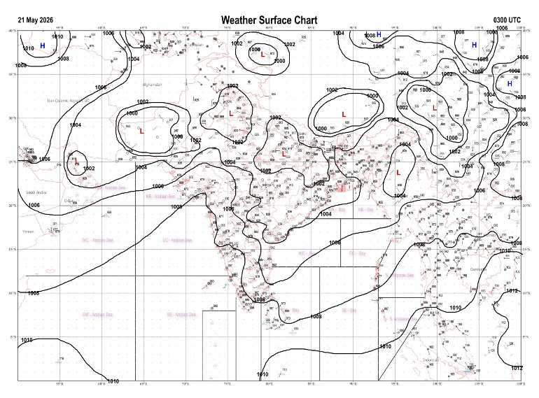 | 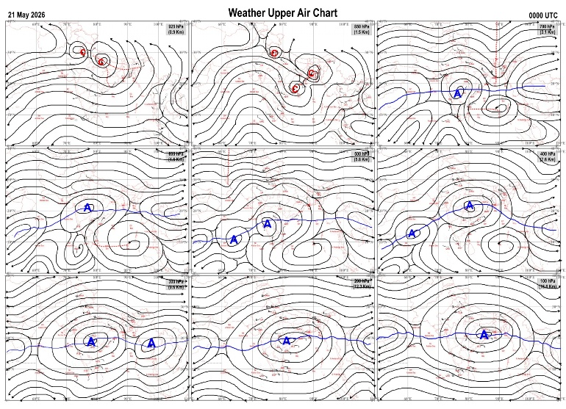
Fig.1. Analysed surface chart based on 03z observation | Fig.2. Analysed upper air chart based on 00z observation
Dr. S.D.Sanap
Scientist ‘D’
CR & S Office, Pune  Issued at 1245 hrs. IST |  | Weather Forecasting Division  CR&S, Pune

Indian regions | Realised rainfall (chief amount in cm during past 24 hrs):
East | many places: Sub-Himalayan West Bengal & Sikkim+  a few places: Gangetic West Bengal  isolated places: Arunachal Pradesh, Assam & Meghalaya, Nagaland-Manipur-Mizoram-Tripura, Odisha, Jharkhand and Bihar+++  Dagarua 13.5, Amfu majhian 11.0, Pranpur 10.9, Denguajhar tea garden 8.7, Jalpaiguri 7.9, Sonari ARG 5.7, Cherrapunji (rkm) & Mawsynram 4.8 each, Purnea 3.2, Basar AWS, Tuli nsdma AWS & Harinkhola 1.9 each, Asansol 1.6, Asansol (CWC) 1.5, Raighar 1.2, Panchet dvc 1.0, Maithon dvc 0.9, Kohima sadar nsdma AWS 0.8, Daporizo AWS, Danagadi & Bolangir 0.7 each, Daparijo 0.6.
North | a few places: Jammu-Kashmir and Ladakh  isolated places: Punjab◆  dry weather: Uttar Pradesh, Uttarakhand, Haryana, Himachal Pradesh and Rajasthan  Nowgam 2.6, Lolab 2.5, Gund 2.1, Faridkot 0.2.
Central | isolated places: Chhattisgarh  dry weather: Madhya Pradesh and Vidarbha  Bhanpuri 0.6, Bastar 0.3.
Peninsula | isolated places: Konkan & Goa◆, Madhya Maharashtra, coastal Andhra Pradesh, Rayalaseema, Tamil Nadu, coastal Karnataka, north interior Karnataka◆, south interior Karnataka and Kerala  dry weather: Gujarat State, Marathwada and Telangana  Kadur 4.8, Arantangi 4.5, Karaikudi 3.4, Nandgaon & Sira 1.9 each, Pamidi 1.4, Yerragondapalem, Raju palem, Kochi IAF & Chavara AWS 0.9 each, Kunnathanam AWS 0.5, Mudubidre 0.4, Kodaikanal 0.2, Honavar & Mangaluru AP 0.1 each.
Islands | many places: Andaman & Nicobar  dry weather: Lakshadweep  Iaf carnicobar 5.1, Hut bay 1.7, Port blair 0.6.
Table-2 Forecast / warnings (distribution of rain / thundershowers) for 7 days (valid from time of origin upto 0830 hrs IST of next day)
Sr N. |  | Sub-division Name | Day 1 | Day 2 | Day 3 | Day 4 | Day 5 | Day 6 | Day 7 | Sr. No. | Sub-division Name | Day 1 | Day 2 | Day 3 | Day 4 | Day 5 | Day 6 | Day 7
 |  |  | 21 May | 22 May | 23 May | 24 May | 25 May | 26 May | 27 May |  |  | 21 May | 22 May | 23 May | 24 May | 25 May | 26 May | 27 May
 | 1 | Andaman Nicobar Islands | W +  | W+ | W  | W  | W | W | W | 19 | west Madhya Pradesh | D + | D + | D + | D + | D + | D + | D+
 | 2 | Arunachal Pradesh | F ++  | W +  | W ++  | W ++  | W ++ | F + | F + | 20 | east Madhya Pradesh | D + | D + | D + | D + | D + | D + | D +
 | 3 | Assam-Meghalaya | F ++  | W +  | W ++  | W ++  | W ++ | F + | F + | 21 | Gujarat region | D | I | I | D | D | D | D
 | 4 | Nagaland-Manipur-Mizoram-Tripura | S +  | S  | F +  | F +  | F | F | F | 22 | Saurashtra and Kutch | D | I | I | D | D | D | D
 | 5 | Sub Him West Bengal/Sikkim | W ++  | W ++  | W ++  | W ++  + | W ++ | W + | W + | 23 | Konkan and Goa | I  | I  | I | I | I | D | D
 | 6 | Gangetic West Bengal | I  + | I  + | I  + | I  + | I | I  + | I  | 24 | Madhya Maharashtra | I  | I  | I | I | I | D | D
 | 7 | Odisha | I  + | I  + | I  + | I  + | I | I  + | I  + | 25 | Marathwada | I | I | I | D | D | D | D
 | 8 | Jharkhand | I  | I+ | I+ | I  | I | S  | S  | 26 | Vidarbha | D + | D + | D + | D + | D + | D + | D +
 | 9 | Bihar | I +  + | I  + | S  + | I +  + | I + | I  | I  | 27 | Chhattisgarh | D + | D + | D + | D + | D + | D | D
 | 10 | east Uttar Pradesh | D + | D + | D + | D + | D + | D+ | D+ | 28 | Coastal Andhra Pradesh and Yanam | I + | I  + | I+ | I + | D + | I | I
 | 11 | west Uttar Pradesh | D + | D + | D + | D + | D + | D+ | D+ | 29 | Telangana | I+ | I  + | D + | D + | D + | D | D
 | 12 | Uttarakhand | I + | S  | S  | I | I + | I | I | 30 | Rayalaseema | I  | I  | I  | I  | I | I | I
 | 13 | Haryana,Chandigarh and Delhi | D + | D + | D + | D + | D + | D + | D + | 31 | Tamil Nadu, Puducherry and Karaikal | I +  + | I +  + | S +  + | S +  + | I + | I +  + | I + +
 | 14 | Punjab | I  + | I  + | D + | D + | D + | D + | D + | 32 | Coastal Karnataka | S  | I  | I  | S  | S | S | S
 | 15 | Himachal Pradesh | I + | S | S  | I | I | I | D | 33 | North interior Karnataka | I  | I  | I  | I  | S | I | I
 | 16 | Jammu-Kashmir and Ladakh | F  | F | S  | S | I | D | D | 34 | South interior Karnataka | S  | S +  | S+ | S +  | S | S | S
 | 17 | west Rajasthan | D + | I  + | D + | D + | D + | D + | D + | 35 | Kerala and Mahe | W +  | F  | F  | F +  | F | F + | F +
 | 18 | east Rajasthan | D + | D + | D + | D + | D + | D + | D+ | 36 | Lakshadweep | W  | F  | F  | F  | F | F | F
Legends: D = Dry I =isolated S = Scattered F = Fairly widespread W = Widespread #= heavy to very heavy rain at a few places with extremely heavy rain at isolated places+++= heavy rain at a few places with very heavy rain at isoIated places++= heavy to very heavy rainfall @=isolated exceptionally heavy rainfall+ = heavy rain ●/*= rain or snow ♦ = very light rain ≡=fog = thunderstorm with lightning =Squall / Gusty / gale / strong wind -=cold wave/cold day + = heat wave/warm night/hot and humid weather =Duststorm =ground frost = Hail.
Fig. 4: Districtwise warnings for five days for Maharashtra State
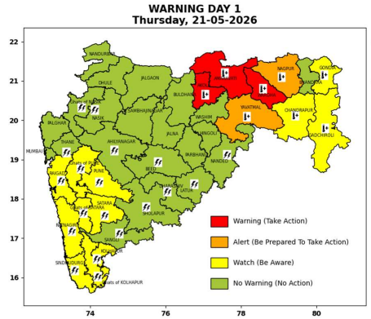 | 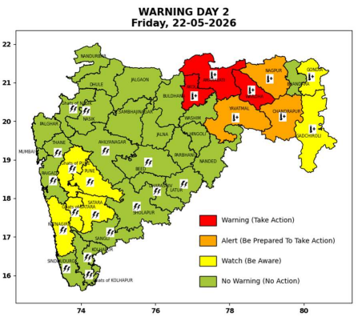 | 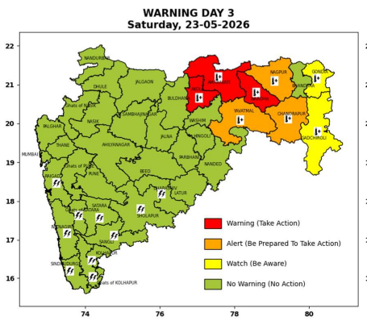 | 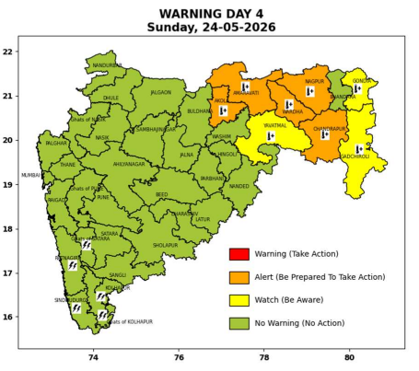 | 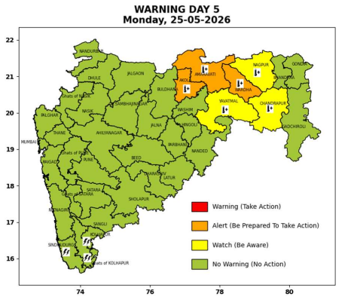

Pune, Lohegaon and Pashan observations at 0830 hrs. IST of Today
 | Temperature (°C) |  |  |  |  | Humidity (%) |  |  |  | Rainfall (mm)
 | Max.  past  24 hrs | Dep.  from  normal | Min.  past  24 hrs. | Dep.  from  normal | Dry  Bulb | At 0830 hrs. IST | Dep.  From  normal | At 1730  hrs. IST of ‘y’day | Dep.  from  normal | Past  24 hrs. | Since  1st March | Dep.  from  normal
PNE | 36.3 | -0.6 | 24.3 | 0.6 | 27.2 | 72 | 9 | 59 | 21 | 0.0 | 92.8 | 61.4
PSN | 36.1 | - | 23.1 | - | 27.0 | 71 | - | 62 | - | 0.0 | - | -
LHG | 38.4 | 1.4 | 25.9 | 4.9 | 29.3 | 53 | -10 | 47 | 11 | 0.0 | 91.4 | 52.4

 |  |  |  |  |  |  | Local (Pune and neighbourhood) forecast
Max./Min. Temperature (°C) |  |  |  |  |  |  |  |  | Weather
Date | Pune | Pashan | Lohegaon | Chinchwad | Lavale | Magarpatta | NDA | Koregoan park
21/05/26 | 39 / 24.3* | 38 / 23.1* | 41 / 25.9* | 38 / 24.8* | 37 / 21.3* | 41 / 25.6* | 37 / 22.4* | 40 / 25.9* | Mainly clear sky becoming partly cloudy sky towards afternoon or evening.
22/05/26 | 38 / 24 | 38 / 23 | 40 / 26 | 38 / 25 | 37 / 21 | 40 / 26 | 37 / 22 | 39 / 26 | Mainly clear sky becoming partly cloudy sky towards afternoon or evening.
23/05/26 | 37 / 24 | 37 / 23 | 39 / 26 | 37 / 25 | 36 / 21 | 39 / 26 | 36 / 22 | 38 / 26 | Mainly clear sky becoming partly cloudy sky towards afternoon or evening.
24/05/26 | 37 / 24 | 37 / 23 | 39 / 26 | 37 / 25 | 36 / 21 | 39 / 26 | 36 / 22 | 38 / 26 | Mainly clear sky becoming partly cloudy sky towards afternoon or evening.
25/05/26 | 37 / 25 | 37 / 24 | 39 / 27 | 37 / 26 | 36 / 22 | 39 / 27 | 36 / 23 | 38 / 27 | Mainly clear sky becoming partly cloudy sky towards afternoon or evening.
26/05/26 | 36 / 25 | 36 / 24 | 38 / 27 | 36 / 26 | 35 / 22 | 38 / 27 | 35 / 23 | 37 / 27 | Mainly clear sky becoming partly cloudy sky towards afternoon or evening.
27/05/26 | 36 / 25 | 36 / 24 | 38 / 27 | 36 / 26 | 35 / 22 | 38 / 27 | 35 / 23 | 37 / 27 | Mainly clear sky becoming partly cloudy sky towards afternoon or evening.
Rainfall Distribution |  |  |  |  | Rainfall Categories | Rainfall (mm) | Cloud condition |  | Rainfall Intensity | Range
Widespread (W) | 76-100% |  |  |  | Very Light rain | Trace to 2.4 mm | Mainly clear sky | 1-2 oktas | Light Spell | 1 cm/hr
 |  |  |  |  | Light rain | 2.5 to 15.5 mm | Partly cloudy sky | 3-4 oktas | Moderate Spell | 1-2 cm/hr
Fairly Widespread (FW) | 51 – 75% |  |  |  | Moderate rain | 15.6 to 64.4 mm | Generally cloudy sky | 5-7 oktas | Intense Spell | 2-3 cm/hr
Scattered (S) | 26 – 50% |  |  |  | Heavy rain | 64.5 to 115.5 mm | Overcast | 8 oktas | Very Intense Spell | 3-5 cm/hr
Isolated (I) | 1 – 25% |  |  |  | Very heavy rain | 115.6 to 204.4 mm |  |  | Extremely Intense Spell | 5-10 cm/hr
Dry (D) | No Rain |  |  |  | Extremely heavy rain | ≥ 204.5 mm |  |  | Cloudburst | > 10 cm/hr
Probability Terms in %: |  |  |  |  | Heavy snow | 6.5 to 11.5 cms water equivalent of rain
unlikely | < 25 |  |  |  | Very heavy snow | 11.6 to 20.4 cms water equivalent of rain
likely | between 25 50
very likely | between 51 75
most likely | >75
* = realized temperature
Mumbai (Colaba) |  |  |  | Nagpur (AP)
Date 2026 | T max °C | T min °C | Weather | T max °C | T min °C | Weather
21/05/26 | 34 | 27 | Clear sky. | 46 | 29 | Heat Wave.
22/05/26 | 35 | 27 | Clear sky. | 45 | 26 | Heat Wave.
23/05/26 | 34 | 27 | Clear sky. | 45 | 26 | Heat Wave.
24/05/26 | 34 | 27 | Clear sky. | 45 | 27 | Heat Wave.
25/05/26 | 34 | 27 | Clear sky. | 45 | 26 | Mainly clear sky.
26/05/26 | 34 | 27 | Clear sky. | 44 | 26 | Mainly clear sky.
27/05/26 | 33 | 27 | Clear sky. | 44 | 26 | Mainly clear sky.

